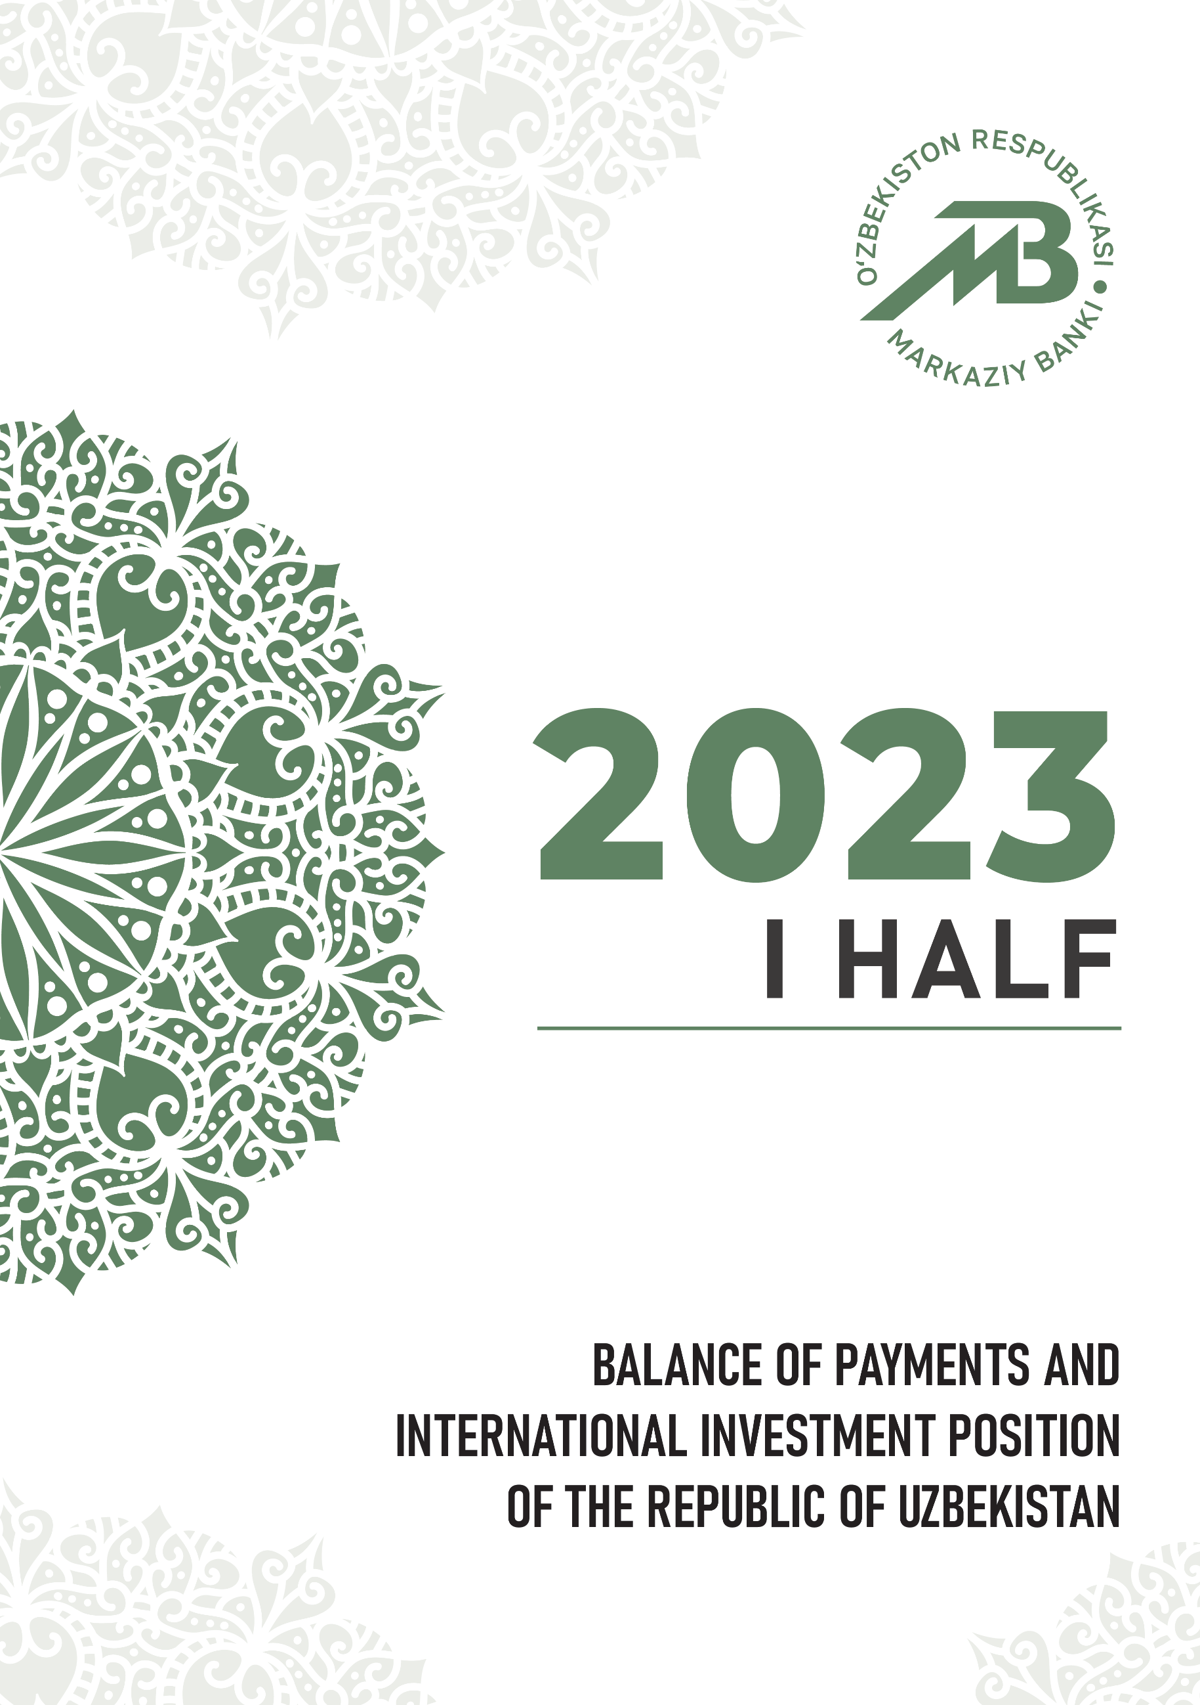

What is the publication about? |  | The publication provides information on the balance of payments and international investment position for  the I half of 2023, which was compiled in accordance with the sixth edition of the Balance of Payments and International Investment Position Manual of International Monetary Fund (BPM6, IMF, 2009).
What date are data relevant? |  | The data, presented in the publication, are relevant  as of September 22, 2023.
Where can data be found? |  | Statistical tables on the standard and analytical presentations of the balance of payments and international investment position are available on websites of  the Central Bank of Uzbekistan http://www.cbu.uz/ and  International Monetary Fund http://data.imf.org/.
Whom to contact with questions and proposals concerning the publication? |  | J. Fayzullaxodjaev  Director of Currency regulation and balance of payments department  (+998) 71 212-60-38 j.fayzullaxodjaev@cbu.uz  O. Tojiddinov  Deputy director of the department –  head of balance of payments division  (+998) 71 212-60-77 o.tojiddinov@cbu.uz  Sh. Khayitboev  Deputy head of balance of payments division  (+998) 71 212-60-42 sh.khayitboev@cbu.uz  Any questions and proposals can also be sent to e-mail address val@cbu.uz.

BRIEF REVIEW

During the I half of 2023, in the conditions of increases in costs of attracting liquidity and vulnerabilities in international financial markets,
a slower-than-expected recovery in economic activity in major trading partners and increased use of transport corridors in the Central Asian region amid logistics disruptions, the current account balance of Uzbekistan was negative and amounted to USD 3.2 bln. (negative balance of USD 637.7 mln. in
the I half of 2022).
In the I half of 2023, the dynamics of the current account remained exposed to risks associated with such factors as the aggravation of the geopolitical situation and high inflation processes in leading economies.
The negative trade (goods and services) balance (USD 7.7 bln.) was partially offset by the positive balance of primary and secondary income
(USD 4.5 bln.).
During the reporting period, external trade turnover amounted to
USD 31.9 bln. (USD 26.7 bln. in the I half of 2022). The volume of export amounted to USD 12.1 bln., and the volume of import – USD 19.8 bln.,
which increased by 16% and 22%, respectively, compared to the I half of
the previous year.
Export of goods amounted to USD 10 bln. and services to USD 2.1 bln., while import of goods and services accounted for USD 16.3 bln.
and USD 3.5 bln., respectively.
The balance of the primary income was positive and accounted for
USD 98.9 mln. (USD 746.4 mln. in the I half of 2022). Moreover,
the positive balance of secondary income amounted to USD 4.4 bln. and remained almost unchanged compared to the corresponding period of the previous year (USD 4.3 bln. in the I half of 2022).
The high growth rate of remittance inflows, occurred in 2022, was observed to return to its historical (fundamental) trends during the reporting period.

In the I half of 2023 the financial account balance was negative and accounted for USD 3.3 bln. (negative balance of USD 709.3 mln. in the I half of 2022).
Financial assets decreased by USD 792.6 mln., in which operations related to other investments increased by USD 1.2 bln., while operations related to international reserve assets decreased by USD 2 bln.
Operations on financial liabilities amounted to USD 2.5 bln, in which direct and other investments accounted for USD 952 mln. and USD 1.5 bln., respectively.
During the reporting period, the net increase in foreign direct investment into share capital amounted to USD 454.6 mln. (USD 369.2 mln. in the I half
of 2022, respectively), whereas the net increase in loans attracted from parent companies accounted for USD 275 mln. (USD 492.2 mln. in the I half of 2022). The net decrease in investment by enterprises operating on the basis of product sharing agreements (PSA) amounted to USD 163.3 mln.
The negative balance of portfolio investments accounted for
USD 3 mln. in the I half of 2023.
The net international investment position of Uzbekistan reduced by 15% (or USD 2.8 bln.) compared to the beginning of 2023 and as of July 1
of 2023 accounted for USD 16.2 bln. The total volumes of assets in the foreign currency and external liabilities of residents were equal to USD 81.4 bln. and USD 65.3 bln., respectively.

Addenda 1. Balance of payments for the I half of 2021-2023
(analytic presentation)
(mln. USD)
Indicators | I half  of 2021 | I half  of 2022 | I half  of 2023
A. Current account balance | -3 339,0 | -637,7 | -3 174,5
Goods, credit (exports) | 5 972,9 | 8 607,4 | 9 955,2
Goods, debit (imports) | 10 633,9 | 12 888,6 | 16 267,1
Services, credit (exports) | 1 004,6 | 1 850,9 | 2 135,6
Services, debit (imports) | 2 162,1 | 3 305,8 | 3 518,5
Balance on goods and services | -5 818,5 | -5 736,1 | -7 694,8
Primary income, credit | 1 115,5 | 2 038,8 | 1 975,7
Primary income, debit | 1 024,5 | 1 292,4 | 1 876,8
Balance on goods, services, and primary income | -5 727,5 | -4 989,7 | -7 595,9
Secondary income, credit | 2 673,9 | 4 801,9 | 4 800,3
Secondary income, debit | 285,4 | 449,9 | 378,8
B. Capital account (excluding reserve assets) | 3,9 | 9,4 | 3,4
Capital account, credit | 3,9 | 9,4 | 3,4
Capital account, debit | 0,0 | 0,0 | 0,0
Balance on capital account and current account | -3 335,1 | -628,3 | -3 171,1
C. Financial account | -2 963,3 | -994,2 | -1 231,2
Direct investment: assets | 1,2 | 2,7 | 10,4
Direct investment: liabilities | 1 326,1 | 880,0 | 951,7
Portfolio investment: assets | 0,0 | 0,0 | 0,2
Equity and investment fund shares | 0,0 | 0,0 | 0,2
Debt securities | 0,0 | 0,0 | 0,0
Portfolio investment: liabilities | 384,5 | 7,7 | 3,1
Equity and investment fund shares | 4,5 | 7,3 | 3,6
Debt securities | 380,0 | 0,3 | -0,5
Financial derivatives (other than reserves) | 6,2 | 5,8 | 1,3
Financial derivatives: assets | 0,0 | 0,0 | 0,0
Financial derivatives: liabilities | -6,2 | -5,8 | -1,3
Other investment: assets | 984,1 | 3 569,8 | 1 218,6
Other equity instruments | 0,6 | 0,4 | 0,4
Debt instruments | 983,5 | 3 569,4 | 1 218,2
Central bank | 0,0 | 0,0 | 0,0
Deposit-taking corporations (except the central bank) | -326,1 | 1 496,5 | -1 646,4
General government | -10,1 | -10,7 | -10,5
Other sectors | 1 319,8 | 2 083,7 | 2 875,0
Other financial corporations | 0,0 | 0,0 | 0,0
Nonfinancial corporations, households, and NPISHs | 1 319,8 | 2 083,7 | 2 875,0
Other investment: liabilities | 2 244,2 | 3 684,8 | 1 506,9
Other equity | 0,0 | 0,0 | 0,0
Debt instruments | 2 244,2 | 3 684,8 | 1 506,9
Central bank | 0,0 | 0,0 | 0,0
Deposit-taking corporations (except the entral bank) | 687,2 | 2 189,1 | 444,2
General government | 467,6 | 339,1 | 664,3
Other sectors | 1 089,4 | 1 156,6 | 398,4
Other financial corporations | 2,6 | 24,9 | 15,7
Nonfinancial corporations, households, and PISHs | 1 086,8 | 1 131,7 | 382,7
D. Net Errors and Omissions | -409,9 | -81,0 | -82,3
E. Overall Balance | 781,7 | -284,9 | 2 022,2
F. Reserves and Related Items | -781,7 | 284,9 | -2 022,2
Reserve assets | -781,7 | 285,2 | -2 021,8
Net credits from the IMF (other than reserves) | 0,0 | 0,2 | 0,4
Exceptional financing | 0,0 | 0,0 | 0,0
This statistic report uses analytic presentation, described in the 6th edition of the Balance of Payments Manual (BPM6).

Addenda 2. International investment position for 2021-2022
and the I half of 2023
(mln. USD)
Indicators | 01.01.2022 | 01.01.2023 | 01.07.2023
Assets | 70 404,0 | 82 293,7 | 81 405,5
Direct investments | 197,7 | 202,0 | 209,6
Equity instruments and investment fund shares | 29,8 | 31,7 | 38,1
Investments of direct investor in direct investment enterprises | 29,8 | 31,7 | 38,1
Investments of direct investment enterprises in direct investor (reverse investment) | 0,0 | 0,0 | 0,0
Investments between fellow enterprises | 0,0 | 0,0 | 0,0
Debt instruments | 167,9 | 170,3 | 171,6
Investments of direct investor in direct investment enterprises | 2,5 | 2,5 | 2,5
Investments of direct investment enterprises in direct investor (reverse investment) | 0,0 | 0,0 | 0,0
Investments between fellow enterprises | 165,4 | 167,9 | 169,1
Portfolio investments | 2,5 | 2,5 | 2,6
Equity instruments and investment fund shares | 2,5 | 2,5 | 2,6
Central Bank | 0,0 | 0,0 | 0,0
Deposit enterprises, excluding the Central Bank | 1,1 | 1,1 | 1,1
General government | 0,0 | 0,0 | 0,0
Other sectors | 1,4 | 1,4 | 1,5
Other financial institutions | 0,0 | 0,0 | 0,0
Debt securities | 0,0 | 0,0 | 0,0
Central Bank | 0,0 | 0,0 | 0,0
Deposit enterprises, excluding the Central Bank | 0,0 | 0,0 | 0,0
General government | 0,0 | 0,0 | 0,0
Other sectors | 0,0 | 0,0 | 0,0
Other financial institutions | 0,0 | 0,0 | 0,0
Financial derivatives (other than reserves) and employee stock options | 0,0 | 0,0 | 0,0
Other investments | 35 064,6 | 46 321,7 | 47 472,9
Other equity instruments | 1,2 | 1,6 | 2,0
Debt instruments | 35 063,4 | 46 320,1 | 47 470,8
Central Bank | 0,0 | 0,0 | 0,0
Deposit enterprises, excluding the Central Bank | 2 935,4 | 4 556,9 | 2 834,9
General government | 3,3 | 3,7 | 4,0
Other sectors | 32 124,7 | 41 759,5 | 44 632,0
Other financial institutions | 0,0 | 0,0 | 0,0
Reserve assets | 35 139,2 | 35 767,5 | 33 720,3
Monetary gold | 20 949,7 | 23 064,8 | 23 087,1
Reserve position in IMF | 0,0 | 0,0 | 0,0
Other reserve assets | 14 189,5 | 12 702,7 | 10 633,2
Liabilities | 53 586,0 | 63 349,0 | 65 252,6
Direct investments | 11 594,1 | 13 649,5 | 14 205,5
Equity instruments and investment fund shares | 10 054,1 | 11 362,0 | 11 656,0
Investments of direct investor in direct investment enterprises | 10 054,1 | 11 362,0 | 11 656,0
Investments of direct investment enterprises in direct investor (reverse investment) | 0,0 | 0,0 | 0,0
Investments between fellow enterprises | 0,0 | 0,0 | 0,0
Debt instruments | 1 540,0 | 2 287,5 | 2 549,5
Investments of direct investor in direct investment enterprises | 1 376,7 | 2 020,8 | 2 247,7
Investments of direct investment enterprises in direct investor (reverse investment) | 0,0 | 0,0 | 0,0
Investments between fellow enterprises | 163,3 | 266,7 | 301,8
Portfolio investments | 4 720,4 | 4 192,1 | 4 229,4
Equity instruments and investment fund shares | 83,5 | 105,8 | 104,2
Central Bank | 0,0 | 0,0 | 0,0
Deposit enterprises, excluding the Central Bank | 37,1 | 48,4 | 46,2
General government | 0,0 | 0,0 | 0,0
Other sectors | 46,4 | 57,4 | 58,1
Other financial institutions | 0,9 | 1,3 | 1,2
Debt securities | 4 636,9 | 4 086,3 | 4 125,2
Central Bank | 0,0 | 0,0 | 0,0
Deposit enterprises, excluding the Central Bank | 993,2 | 893,9 | 923,7
General government | 2 669,2 | 2 375,0 | 2 353,0
Other sectors | 974,5 | 817,3 | 848,5
Other financial institutions | 0,0 | 0,0 | 0,0
Financial derivatives (other than reserves) and employee stock options | 11,5 | 2,0 | 1,0
Other investments | 37 259,9 | 45 505,4 | 46 816,7
Other equity instruments | 0,0 | 0,0 | 0,0
Other debt instruments | 37 259,9 | 45 505,4 | 46 816,7
Central Bank | 0,0 | 0,0 | 0,0
Deposit enterprises, excluding the Central Bank | 6 766,0 | 10 439,7 | 10 841,9
General government | 15 290,6 | 18 007,8 | 18 579,7
Other sectors | 15 203,2 | 17 058,0 | 17 395,1
Other financial institutions | 72,2 | 103,9 | 114,1
Net international investment position | 16 818,1 | 18 944,8 | 16 152,9

