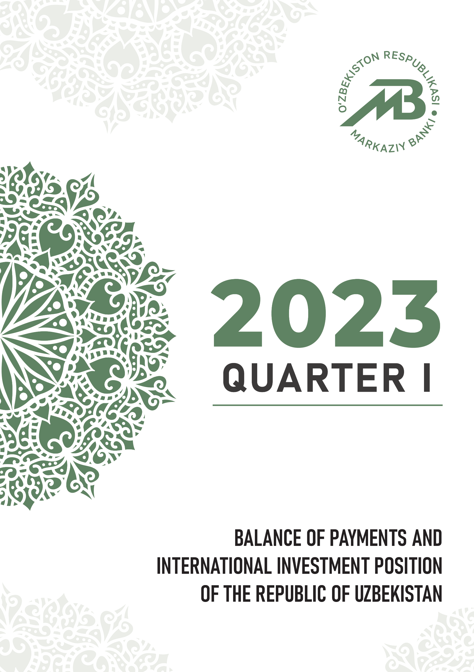

What is the publication about? |  | The publication provides information on the balance of payments and international investment position, which was compiled in accordance with the sixth edition of the Balance of Payments and International Investment Position Manual of International Monetary Fund (BPM6, IMF, 2009).
What date are data relevant? |  | The data, presented in the publication, are relevant  as of June 27, 2023.
Where can data be found? |  | Statistical tables on the standard and analytical presentations of the balance of payments and international investment position are available on websites of  the Central Bank of Uzbekistan http://www.cbu.uz/ and  International Monetary Fund http://data.imf.org/.
Whom to contact with questions and proposals concerning the publication? |  | J. Fayzullaxodjaev  Director of Currency regulation and balance of payments department  (+998) 71 212-60-38 j.fayzullaxodjaev@cbu.uz  O. Tojiddinov  Deputy director of the department –  head of balance of payments division  (+998) 71 212-60-77 o.tojiddinov@cbu.uz  Sh. Khayitboev  Deputy head of balance of payments division  (+998) 71 212-60-42 sh.khayitboev@cbu.uz  S. Yunusov  Head of current account subdivision  (+998) 71 212-58-71 s.yunusov@cbu.uz  Any questions and proposals can also be sent to  e-mail address val@cbu.uz.

BRIEF REVIEW
In the I quarter of 2023, in the context of improving expectations regarding the growth indicators of global economies, reducing difficulties in transport and logistics, as well as a slow recovery in economic activity among major trading partners (particularly China) and increasing vulnerabilities in international financial markets, the current account balance of Uzbekistan was negative and amounted to USD 1.3 bln. (the negative balance in the
I quarter of 2022 was USD 1.1 bln.).
At the same time, during the I quarter of 2023, the dynamics of the current account remained exposed to risks associated with such factors as the aggravation of the geopolitical situation, the formation of high rates of global inflationary processes, and an increase in the cost of attracting funds from international financial markets.
The negative trade (goods and services) balance (USD 3.6 bln.) was partially offset by the positive balance of primary and secondary income
(USD 2.3 bln.).
During the reporting period, external trade turnover (excluding gold) amounted to USD 12.9 bln. (USD 11.1 bln. in the I quarter of 2022). At the same time, the volume of exports (without gold) amounted to USD 3.4 bln.,
and the volume of imports – USD 9.4 bln., which increased by 16%, respectively, compared to the I quarter of last year.
Exports of goods (excluding gold) amounted to USD 2.5 bln. and services to USD 897.1 mln., while imports of goods and services accounted for
USD 7.7 bln. and USD 1.7 bln., respectively.
Balance of the primary income accounted for USD 314.8 mln. during the
reporting period (USD 505.8 mln. in the I quarter of 2022). In addition,
the positive balance of secondary income amounted to USD 2 bln. due to
a sizable increase in personal transfers compared to the corresponding period of the previous year (USD 646.9 mln. in the I quarter of 2022).

In the I quarter of 2023 the financial account balance was negative and accounted for USD 1.3 bln. (negative balance of USD 994.5 mln. in the I quarter of 2022). In the asset part of the financial account, a volume of operations related to other investments increased by USD 752.6 mln., whereas a volume of operations related to international reserve assets decreased by USD 1.5 bln.
In the liability part of the financial account, mainly direct investments and other investments increased by USD 171 mln. and USD 322 mln., respectively.
The net growth of foreign direct investments to Uzbekistan was provided
by net investments in capital (excluding operations of enterprises operating on the basis of product sharing agreements - USD 114.6 mln.), loans attracted from parent companies (USD 93.6 million) and net disbursement of investments by enterprises operating on the basis of product sharing agreements (USD 96.5 million).
The negative balance of portfolio investments accounted for
USD 14.3 mln. in the I quarter of 2023.
The net international investment position of Uzbekistan increased by 1% (USD 165.2 mln.) compared to the beginning of 2023 and as of April 1
of 2023 accounted for USD 19 bln. The total volumes of assets in the foreign currency and external liabilities of residents were equal to USD 82.6 bln. and USD 63.6 bln., respectively.

Addenda 1. Balance of payments for the I quarter of 2021-2023
(analytic presentation)
(mln. USD)
Indicators | I quarter  of 2021 | I quarter  of 2022 | I quarter  of 2023
A. Current account balance | -2 135,3 | -1 090,8 | -1 273,9
Goods, credit (exports) | 1 947,7 | 5 248,6 | 4 941,7
Goods, debit (imports) | 4 708,7 | 6 518,2 | 7 726,0
Services, credit (exports) | 430,2 | 670,5 | 897,1
Services, debit (imports) | 895,6 | 1 644,4 | 1 719,3
Balance on goods and services | -3 226,3 | -2 243,5 | -3 606,6
Primary income, credit | 337,2 | 956,3 | 1 029,9
Primary income, debit | 372,7 | 450,5 | 715,1
Balance on goods, services, and primary income | -3 261,8 | -1 737,8 | -3 291,8
Secondary income, credit | 1 237,0 | 867,0 | 2 204,5
Secondary income, debit | 110,5 | 220,0 | 186,6
B. Capital account (excluding reserve assets) | 1,8 | 8,2 | 1,2
Capital account, credit | 1,8 | 8,2 | 1,2
Capital account, debit | - | - | -
Balance on capital account and current account | -2 133,6 | -1 082,7 | -1 272,6
C. Financial account | -844,2 | -1 089,0 | 255,3
Direct investment: assets | 0,6 | 2,1 | 9,6
Direct investment: liabilities | 437,3 | 312,1 | 170,9
Portfolio investment: assets | - | - | 0,2
Equity and investment fund shares | - | - | 0,2
Debt securities | - | - | -
Portfolio investment: liabilities | 12,3 | 6,7 | 14,5
Equity and investment fund shares | 0,7 | -5,2 | 2,5
Debt securities | 11,6 | 12,0 | 11,9
Financial derivatives (other than reserves) | 3,2 | 2,8 | 0,5
Financial derivatives: assets | - | - | -
Financial derivatives: liabilities | -3,2 | -2,8 | -0,5
Other investment: assets | 355,7 | -441,8 | 752,6
Other equity instruments | 0,6 | - | 0,4
Debt instruments | 355,1 | -441,8 | 752,2
Central bank | - | - | -
Deposit-taking corporations (except the central bank) | -117,5 | -34,2 | -611,0
General government | -5,7 | -6,1 | -7,0
Other sectors | 478,3 | -401,5 | 1 370,1
Other financial corporations | - | - | -
Nonfinancial corporations, households, and NPISHs | 478,3 | -401,5 | 1 370,1
Other investment: liabilities | 754,1 | 333,3 | 322,2
Other equity | - | - | -
SDR allocation | -0,0 | 0,3 | 1,0
Debt instruments | 754,1 | 333,1 | 321,2
Central bank | - | - | -
Deposit-taking corporations (except the entral bank) | 506,9 | -127,0 | 280,9
General government | 51,0 | 163,4 | 378,8
Other sectors | 196,2 | 296,6 | -338,4
Other financial corporations | 2,6 | 4,1 | 4,7
Nonfinancial corporations, households, and PISHs | 193,5 | 292,5 | -343,1
D. Net Errors and Omissions | 1,0 | 88,0 | -21,0
E. Overall Balance | 1 288,4 | -94,4 | 1 549,0
F. Reserves and Related Items | -1 288,4 | 94,4 | -1 549,0
Reserve assets | -1 288,4 | 94,4 | -1 548,7
Net credits from the IMF (other than reserves) | -0,0 | 0,0 | 0,2
Exceptional financing | - | - | -
This statistic report uses analytic presentation, described in the 6th edition of the Balance of Payments Manual (BPM6).

Addenda 2. International investment position for 2021-2022
and the I quarter of 2023
(mln. USD)
Indicators | 01.01.2022 | 01.01.2023 | 01.04.2023
Assets | 70 404,0 | 82 172,9 | 82 584,9
Direct investments | 197,7 | 202,0 | 210,4
Equity instruments and investment fund shares | 29,8 | 31,7 | 39,4
Investments of direct investor in direct investment enterprises | 29,8 | 31,7 | 39,4
Investments of direct investment enterprises in direct investor (reverse investment) | 0,0 | 0,0 | 0,0
Investments between fellow enterprises | 0,0 | 0,0 | 0,0
Debt instruments | 167,9 | 170,3 | 171,0
Investments of direct investor in direct investment enterprises | 2,5 | 2,5 | 2,5
Investments of direct investment enterprises in direct investor (reverse investment) | 0,0 | 0,0 | 0,0
Investments between fellow enterprises | 165,4 | 167,9 | 168,5
Portfolio investments | 2,5 | 2,5 | 2,7
Equity instruments and investment fund shares | 2,5 | 2,5 | 2,7
Central Bank | 0,0 | 0,0 | 0,0
Deposit enterprises, excluding the Central Bank | 1,1 | 1,1 | 1,1
General government | 0,0 | 0,0 | 0,0
Other sectors | 1,4 | 1,4 | 1,5
Other financial institutions | 0,0 | 0,0 | 0,0
Debt securities | 0,0 | 0,0 | 0,0
Central Bank | 0,0 | 0,0 | 0,0
Deposit enterprises, excluding the Central Bank | 0,0 | 0,0 | 0,0
General government | 0,0 | 0,0 | 0,0
Other sectors | 0,0 | 0,0 | 0,0
Other financial institutions | 0,0 | 0,0 | 0,0
Financial derivatives (other than reserves) and employee stock options | 0,0 | 0,0 | 0,0
Other investments | 35 064,6 | 46 200,9 | 46 934,4
Other equity instruments | 1,2 | 1,6 | 2,0
Debt instruments | 35 063,4 | 46 199,3 | 46 932,3
Central Bank | 0,0 | 0,0 | 0,0
Deposit enterprises, excluding the Central Bank | 2 935,4 | 4 556,9 | 3 921,8
General government | 3,3 | 3,7 | 2,9
Other sectors | 32 124,7 | 41 638,7 | 43 007,6
Other financial institutions | 0,0 | 0,0 | 0,0
Reserve assets | 35 139,2 | 35 767,5 | 35 437,5
Monetary gold | 20 949,7 | 23 064,8 | 24 254,8
Special drawing rights | 1 111,9 | 1 057,3 | 1 068,8
Reserve position in IMF | 0,0 | 0,0 | 0,0
Other reserve assets | 13 077,6 | 11 645,4 | 10 113,9
Liabilities | 53 573,0 | 63 304,5 | 63 551,2
Direct investments | 11 593,9 | 13 647,0 | 13 491,2
Equity instruments and investment fund shares | 10 053,9 | 11 361,7 | 11 130,3
Investments of direct investor in direct investment enterprises | 10 053,9 | 11 361,7 | 11 130,3
Investments of direct investment enterprises in direct investor (reverse investment) | 0,0 | 0,0 | 0,0
Investments between fellow enterprises | 0,0 | 0,0 | 0,0
Debt instruments | 1 540,0 | 2 285,3 | 2 360,8
Investments of direct investor in direct investment enterprises | 1 376,7 | 2 022,0 | 2 095,9
Investments of direct investment enterprises in direct investor (reverse investment) | 0,0 | 0,0 | 0,0
Investments between fellow enterprises | 163,3 | 263,3 | 264,9
Portfolio investments | 4 720,4 | 4 192,1 | 4 186,4
Equity instruments and investment fund shares | 83,5 | 105,9 | 106,5
Central Bank | 0,0 | 0,0 | 0,0
Deposit enterprises, excluding the Central Bank | 37,1 | 48,4 | 50,3
General government | 0,0 | 0,0 | 0,0
Other sectors | 46,4 | 57,5 | 56,2
Other financial institutions | 0,9 | 1,4 | 1,3
Debt securities | 4 636,9 | 4 086,3 | 4 079,9
Central Bank | 0,0 | 0,0 | 0,0
Deposit enterprises, excluding the Central Bank | 993,2 | 893,9 | 926,0
General government | 2 669,2 | 2 375,0 | 2 319,1
Other sectors | 974,5 | 817,3 | 834,8
Other financial institutions | 0,0 | 0,0 | 0,0
Financial derivatives (other than reserves) and employee stock options | 11,5 | 2,0 | 0,9
Other investments | 37 247,2 | 45 463,3 | 45 872,8
Other equity instruments | 0,0 | 0,0 | 0,0
Special drawing rights (Net incurrence of liabilities) | 1 107,3 | 1 057,6 | 1 070,1
Other debt instruments | 36 139,9 | 44 405,7 | 44 802,7
Central Bank | 0,0 | 0,0 | 0,0
Deposit enterprises, excluding the Central Bank | 6 766,0 | 10 439,4 | 10 739,8
General government | 15 290,6 | 18 006,8 | 18 436,9
Other sectors | 14 083,2 | 15 959,5 | 15 626,0
Other financial institutions | 72,2 | 103,9 | 107,8
Net international investment position | 16 831,1 | 18 868,5 | 19 033,7

